Results

II. Machine learning on synthetic data
We proceeded to create a machine learning model with our synthetic data as the training and validating data. Because the synthetic data does not contain unexplained errors like the TCGA data, it is more reliable for creating a robust machine learning model.
To-do: make everything binary classification


The random forest algorithm was used, and to account for the imbalance between the passenger and driver class, we applied the RUSBoost algorithm, which reduces bias towards the majority class through a iterative sampling method that prioritizes the correction of a previously misclassified item (Seiffert et al.). Results of 15% hold-out validation on the classifier is reported in Table 1. The classifier’s accuracy well exceeds 90% and its Cohen’s kappa, a measure of accuracy that is adjusted for chance selection, exceeds 0.8.

III. Validation of putative cancer driver genes from TCGA

a. Statistical analysis and driver gene ranking
Cancer Name | Accuracy | Precision | Recall | P-value
Colorectal | 85.8%
Pancreatic | 85.6%
Breast | 86.9%
Melanoma | 87.2%
New Paragraph Lorem ipsum dolor sit amet, consectetur adipiscing elit, sed do eiusmod tempor incididunt ut labore et dolore magna aliqua. Ut enim ad minim veniam, quis nostrud exercitation ullamco laboris nisi ut aliquip ex ea commodo consequat. Duis aute irure dolor in reprehenderit in voluptate velit esse cillum dolore eu fugiat nulla pariatur. Excepteur sint occaecat cupidatat non proident, sunt in culpa qui officia deserunt mollit anim id est laborum

Having validated our driver gene classifier with the synthetic dataset, we applied it to four cancer types in the TCGA dataset: colorectal cancer, pancreatic cancer, breast cancer, and melanoma. This approach identified 118, 531,1673, and 1660 driver genes in each respective cancer type, including most well-known mutations (e.g. oncogenes like BRAF, tumor suppressors like TP53).

b. Cross-reference with CGC and NCBI
We found that our classifier identifies key driver genes included in the cancer census gene (CGC) list, which was downloaded from COSMIC as a reference list for generally accepted cancer genes. The number of oncogenes, tumor suppressor genes, and driver genes (without regards to type) that are reported as driver genes by both CGC and our classifier are reported in Table 2.
To initialize our analysis of the top genes predicted by our classifier, we ranked the putative driver genes according to their driver scores. Driver scores were calculated as the combined probability of the gene being either a driver oncogene or tumor suppressor gene; this is the equivalent of the fraction of observations of the OG and TSG classes in the nodes of the random forest ensemble. After the putative drivers were ranked, a clear CGC gene enrichment was found for the top ranked genes for the four types analyzed (Table 2). On average, 62.5%, 29.1% and 23.0% of the top 10, 30 and 50 selected genes were CGC documented driver genes. The first column of Table 3 reports the names of the top fifteen putative driver genes that are also reported CGC driver genes; the second column reports the number of publication hits in NCBI which are found to be relevant to a query cancer type plus a query gene. The top CGC-validated putative genes are apparently more likely genes that have well-documented relevance to the cancer type.
Cancer Name | # OG overlap | # TSG overlap | # drivers overlap | Recall: top 10 | Recall: top 30 | Recall: top 50
Colorectal | 26 | 12 | 66 | 70.0% | 33.3% | 24.0%
Pancreatic | 17 | 12 | 51 | 50.0% | 20.0% | 18.0%
Breast | 32 | 12 | 75 | 70.0% | 33.3% | 26.0%
Melanoma | 35 | 13 | 80 | 60.0% | 30.0% | 24.0%
Table 2. Performance of synthetic data-validated random forest classifier on driver gene classification in individual datasets of TCGA cancers.
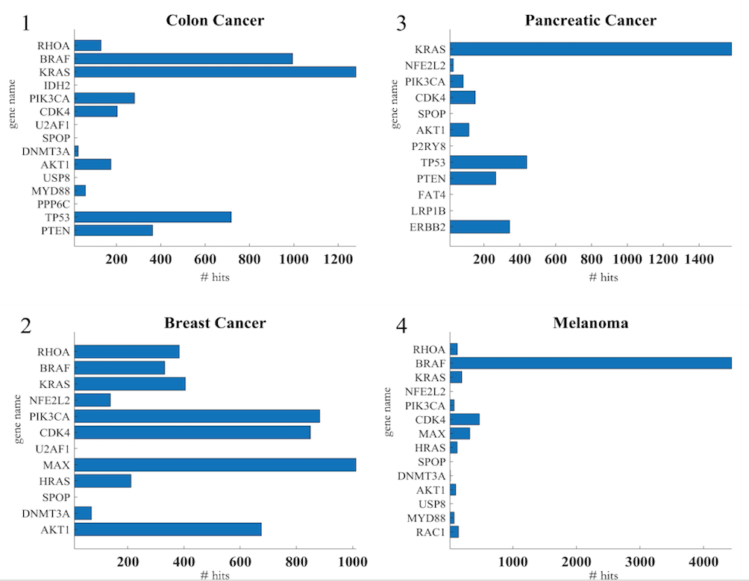

Table 3. The names and NCBI publication hits of the top fifteen ranked putative genes

c. Pathway analysis
We additionally validated that the identified driver genes are active in biological pathways through a pathway analysis with the Kyoto Encyclopedia of Genes and Genomes (KEGG) (Ogata et al.); the identified putative driver genes across the four cancer types were shown to be active in pathways involved in cell development and apoptosis, including PI3K-AKT and Wnt/β-Catenin. (The full pathway is included in the Appendix.)
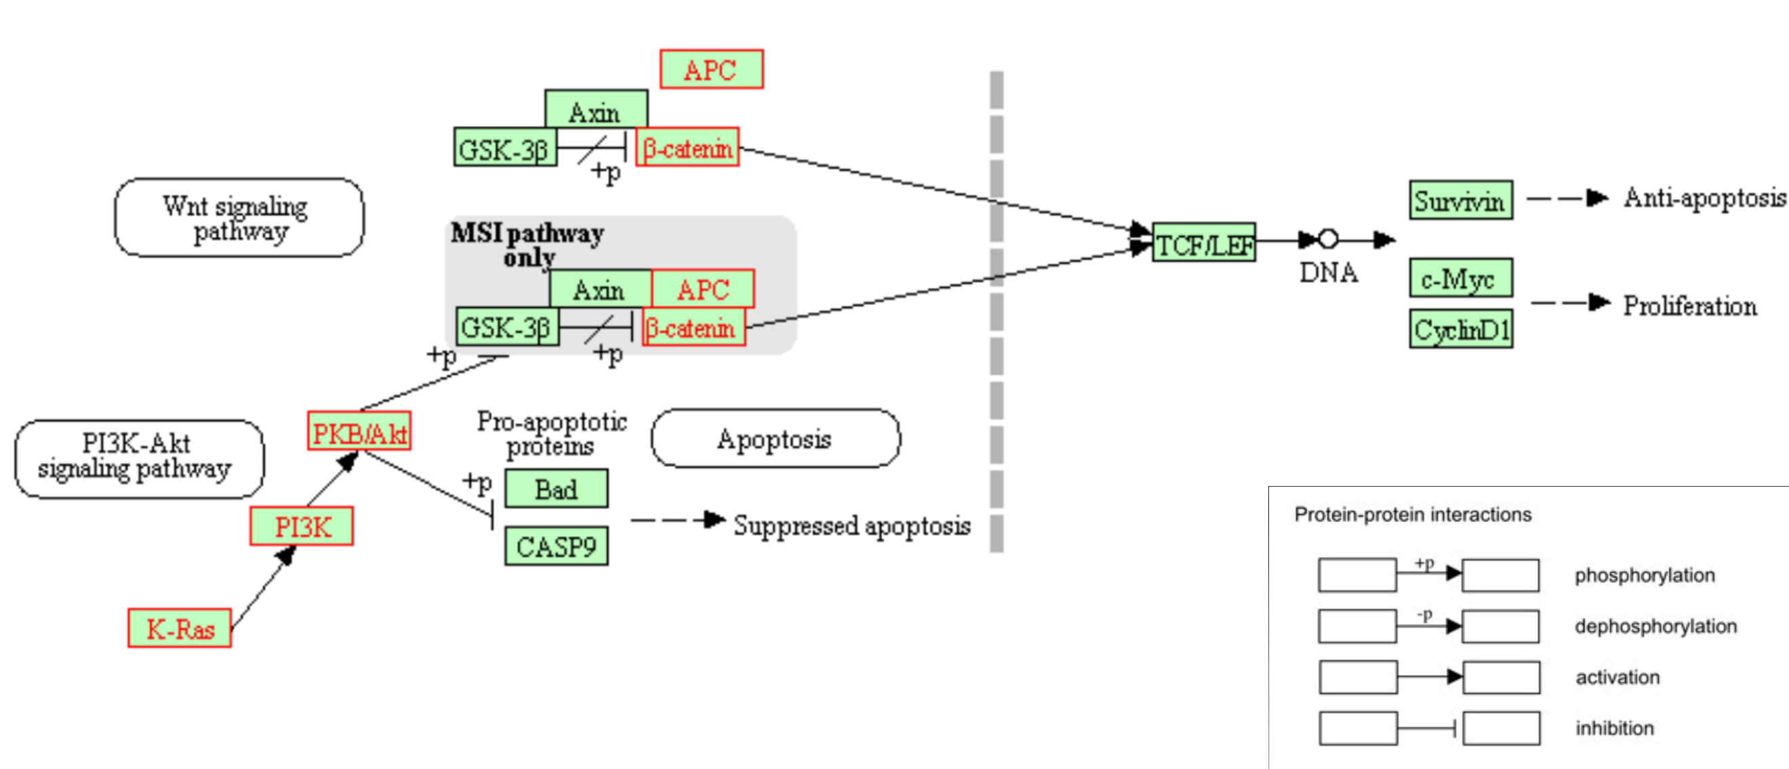Figure 3. Interaction pathway of select colorectal cancer driver genes identified by our classifier. The proteins typed in red are affiliated with genes identified by our classifier as a driver.

Phosphatidyl-inositol 3-kinase (PI3K) activity is associated with the transformation of viral oncoproteins; PI3K (encoded by PIK3CA, etc.) is central in several cellular processes, such as proliferation, growth, apoptosis, and cytoskeletal rearrangement. The primary consequence of PI3K activation is the generation of the second messenger PIP₃, which activates downstream pathways that involve proteins involving AKT and others. The phosphatase PTEN terminates the PI3K-AKT signaling pathway by dephosphorylating PIP₃ to PIP₂. Mutations on genes in the pathway --- PIK3CA, AKT1, and PTEN --- lead to aberrant pathway activation, and often, carcinogenesis. Our method is able to prioritize this signaling motif: lists of top ten driver genes for each of the four cancer types include at least two of these three PI3K pathway genes.
Another signaling pathway implicated in the driver genes returned by our method is the Wnt pathway. Signaling by the Wnt proteins via the transcription co-activator β-catenin controls embryonic development and adult homeostasis. β-catenin (encoded by CTNNB1) is regulated and destroyed by the beta-catenin destruction complex, and in particular by the adenomatous polyposis coli (APC) protein, encoded by the tumor-suppressing APC gene. The loss of negative Wnt signaling regulation by APC is responsible for around 15% of colorectal cancer cases.
We were able to construct a signaling pathway of colorectal cancer carcinogenesis based upon the list of predicted genes active in either the Wnt or PI3K pathway. Figure 3 is retrieved from KEGG as is a partial summary of the pathway. Products of the KRAS (driver score rank #3), PIK3CA (rank #5), AKT1 (rank #10), APC (rank #25), and CTNNB1 (rank #43) genes are depicted (Appendix).

